Technical Document

for

Jelblob: The Horrific Adventure

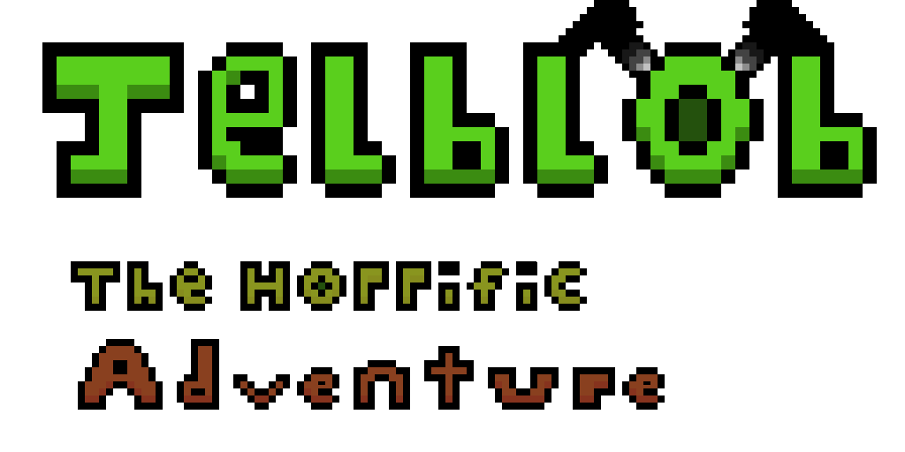

Table of Content

Role Assignments 3

Overview 3

Project Brief 3

Project Goal 3

Software 4

Hardware 4

Software Development 5

Methodology (explain how used in the development of the game) 5

Production – Assets and Audio 5

Pseudocode (screen shots of code in document or appendices) 5

(UML – Class Diagrams – Steven) 5

Testing – Justification of testing approaches adopted 5

Test plan (relate this to Quality Assurance) 5

Test Log 5

Evaluation of the prototype 5

Video demo (copy url into document) 5

# Role Assignments

|  |  |  |  |
| --- | --- | --- | --- |
| **Name** | **Banner ID** | **Course** | **Role in Project** |
| Alistair Walker | B00305911 | Computer Games Technology | Lead Artist  (With sub roles in Design and Programming) |
| **Description** | | | |
| My role was to provide concept drawings while producing the artwork based on concepts; creating sprites for the characters, blocks and background while making sure each one had an animation provided along with it. I also had sub roles in design and programming, providing feedback on Game Design choices and programming.  I choose the role of Lead Artist because I wanted more experience in art, as previous roles I have undertook in the past of Games Designer and programming; art is a subject I have not touched often, and I believe it’s important to be able to create your own assets. | | | |
| Kenny Melvillie | B00323186 | Games Development | Lead Games Designer, Audio Designer  (With sub roles in Programming and Artist) |
| **Description** | | | |
|  | | | |
| Steven O’neill | B00339826 | Games Development | Lead Programmer  (With sub roles in Artist and Design) |
| **Description** | | | |
|  | | | |

# Overview

## Project Brief

The purpose of this project, is to develop a working prototype of game as a project team that follows closely to the team’s design and technical design documents. The project team can choose any genre for their specific game, either from a 2D or 3D perspective using the appropriate game engine (Unity, Unreal Engine 4 or Game Maker) to aid their implementation requirements.

For our project, we have tasked ourselves with creating a 2D Side-Scrolling Platformer titled “Jelblob: The Horrific Adventure”, using the game engine ‘Unity’ for development of the title, and coding the game using C# in Visual Studios.

## Project Goal

The aim of this project is to create a playable prototype with at least one level that can be played from start to end. The player controlled character should be able to move left/right and being able to jump as well as firing projectiles, and should be able to end the level by passing a goal which the player must traverse hazards and enemies along the way.

## Software

|  |  |
| --- | --- |
| **Software Used** | **Description** |
| Unity 2017 | The Game Engine that is used for developing the game. |
| Visual Studios 2017 | The Software that is used to code the game. |
| Audacity | The program that is used for recording and editing audio into a suitable format for Unity. |
| Aseprite | The software that is used for the creation of sprite assets (characters, objects, background etc.) and other forms of artwork for Unity. |
| Microsoft Word | The software that is used for the documentation of the project, writing down the design and technical documents. |
| Microsoft PowerPoint | The software that is used to present the game to the audience in a presentation manner. |

## Hardware

|  |
| --- |
| * PC Name – UWS Computer (E113b) * Edition – Windows 10 Enterprise * Processor – Intel(R) Xeon(R) CPU E3-1245 v3 @ 3.40GHz * Installed RAM – 16.0GB * System Type - 64-bit Operating System, x64 Based Processor |

|  |
| --- |
| * PC Name – Firedudeet-PC * Edition – Windows 10 Home * Processor – Intel(R) Core™ i5-3570K CPU @3.40GHz 3.40GHz * Installed RAM – 16.0GB * System Type – 64-bit operating system, x64-based processor |

|  |
| --- |
| * PC Name – DESKTOP-TKITQQ1 * Edition – Windows 10 Home * Processor – Intel(R) Core(TM) i7-6700HQ CPU @ 2.60GHz 2.59Ghz * Installed RAM – 8.00GB * System Type – 64-bit operating system, x64-based processor |

# Software Development

## Methodology (explain how used in the development of the game)

## Production – Assets and Audio

## Pseudocode (screen shots of code in document or appendices)

## (UML – Class Diagrams – Steven)

UI (detail this here)

# Testing – Justification of testing approaches adopted

## Test plan (relate this to Quality Assurance)

## Test Log

## Evaluation of the prototype

## Video demo (copy url into document)